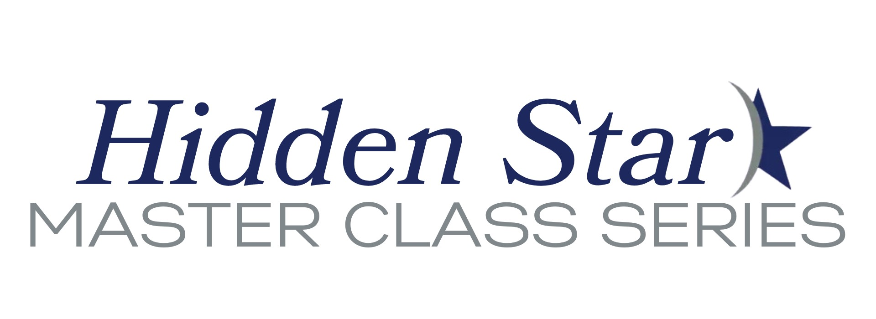

To Address Systemic Inequities Hidden Star releases new
Master Class: Entrepreneurship for Women and Minority founders

Hidden Star Helps Fund Entrepreneurial Success

October 17, 2023

Austin, TX - Hidden Star Resources announces the release of a new Master Class for women and minority entrepreneurs; to help more entrepreneurs not only start and grow their own businesses but to also help them reduce risk. At a time in this country of unprecedented disparities in wealth, ownership, and economic opportunity, this course, led by two world renowned experts and successful business owners, will provide a proven, easy to follow road map for those who are wanting to change their journey and their future. Funds raised from this course support Hidden Star’s important work helping women and minority businesses.

“Business success is the foundation of this course and the information included is crucial in today’s climate,” says Dr. John Sibley Butler, a course co-instructor.

Butler is a world-renowned expert and author on minority entrepreneurship and wealth creation in the minority business community and is a Chairman Emeritus at the University of Texas at Austin McCombs Business School. Co-instructor Mike Dewey is the visionary founder of Hidden Star, a four-time entrepreneur, and a widely published business author. Drawing from their vast and relevant experience, this course provides entrepreneurs with step-by-step instructions on how to build a successful and sustainable business.

“Since the beginning of Hidden Star” said Dewey, “we have helped thousands of new, aspiring, and experienced entrepreneurs and we know exactly what they need to succeed. We have packed it all into this class. People taking this class can go from disadvantaged to highly advantaged in about five hours. It really can change the game and change their lives.”

Dr. Butler is a life-long proponent of minority entrepreneurship and comments on the timeliness of this Master Class, “This class is badly needed today and is tailored specifically to teach material you will not find anywhere else. Unfortunately, it is different and harder for these entrepreneurs and we teach them how to play and win”, says Butler.

Dallas entrepreneur Isaac Williams worked with Hidden Star when starting his staffing company and says “Starting my own company has changed my life and I couldn’t have done it without Hidden Star and the information in this Master Class. I hope it changes your life like it changed mine,” says Williams.

All too often, entrepreneurship coaching and instruction leave out important and unique factors and issues that confront women and minority business community but this class focuses on them. In addition to the business basics that everyone needs, this Hidden Star Master Class also provides them with in-depth training and education on the financing and revenue opportunities that exist for them to take advantage of, but are not widely known.

“We designed and delivered this course for one reason, to give new and potential entrepreneurs the knowledge of how to start and grow their own company as well as the confidence to know that they, too can be a successful business owner. America needs more successful minority and women owned businesses and we are proud to help,” says Dewey.

The Master Class is available online at www.hiddenstarlearning.org
FOR MORE INFORMATION:
Mike Dewey
mdewey@hiddenstar.org

ABOUT HIDDEN STAR

Dedicated to the notion that America is better with more successful minority and women owned businesses, Hidden Star Resources is a non-profit 501(c)(3) based in Austin, Texas. Since 2016 Hidden Star has helped, at no cost, countless minority and women entrepreneurs start and grow their own companies. We are proud to be a two-time recipient of Department of Commerce / Economic Development Administration grants for assistance to disadvantaged business owners. Hidden Star offers help nationwide. The Hidden Star online project providing free support, Galaxy of Stars, now has more than 300,000 members and is growing rapidly.

See more at: www.galaxyofstars.org and www.hiddenstar.org
###

